1)

Cases
Optimal case above is 2

Unless otherwise specified, all descriptions below have default settings when opening Design Analyzer. Design Analyzer was restarted for each case. Design Optimization was run multiple times with mapping effort changed – starting with the lowest setting and incrementally increased to indicated mapping effort for each case below.

All Low cases above were performed with low mapping effort

1) Medium mapping effort
Structure logic on (timing driven structuring on, boolean Optimization on)

2) (OPTIMIAL CASE)
High mapping effort
Structure logic off

3) High mapping effort
Structure logic off
Boundary Optimization on

4) High mapping effort
Structure logic on (timing driven structuring off, boolean Optimization on)

5) Medium mapping effort
Structure logic off
Flatten Logic on (high effort, multiple output, apply strategy)

6) High mapping effort
Structure logic on (timing driven structuring on, Boolean optimization on)
Flatten Logic on (high effort, multiple output, apply strategy)
Boundary Optimization on

2)

****************************************
Report : area
Design : FA
Version: X-2005.09
Date : Mon Mar 16 13:28:36 2015
****************************************

Library(s) Used:

ece451_cells (File: /cad2/ece451/synopsys/ece451_cells.db)

Number of ports: 6
Number of nets: 20
Number of cells: 13
Number of references: 7

Combinational area: 617.399902
Noncombinational area: 1393.559937
Net Interconnect area: 0.284977

Total cell area: 2010.959961
Total area: 2011.244873
1
design_analyzer>
****************************************
Report : timing
-path full
-delay max
-max_paths 1
Design : FA
Version: X-2005.09
Date : Mon Mar 16 13:28:36 2015
****************************************

Operating Conditions: nom_pvt Library: ece451_cells
Wire Load Model Mode: top

Startpoint: a_reg (rising edge-triggered flip-flop clocked by clk)
Endpoint: sum_out_reg
(rising edge-triggered flip-flop clocked by clk)
Path Group: clk
Path Type: max

Des/Clust/Port Wire Load Model Library
------------------------------------------------
FA q35_27k ece451_cells

Point Incr Path
-----------------------------------------------------------
clock clk (rise edge) 0.00 0.00
clock network delay (ideal) 0.00 0.00
a_reg/C (fdp2) 0.00 0.00 r
a_reg/Q (fdp2) 0.57 0.57 f
U38/Q (xo2p2) 0.40 0.97 r
U34/NQ (xn2p2) 0.31 1.28 r
sum_out_reg/D (fdp1) 0.00 1.28 r
data arrival time 1.28

clock clk (rise edge) 1.38 1.38
clock network delay (ideal) 0.00 1.38
sum_out_reg/C (fdp1) 0.00 1.38 r
library setup time -0.09 1.29
data required time 1.29
-----------------------------------------------------------
data required time 1.29
data arrival time -1.28
-----------------------------------------------------------
slack (MET) 0.01

3) Simulation

quartus.start was used to do the simulation. An R-S simulation was used. First we do an R+S with R=D and S=0, then we save it into memory location 1. On the next cycle we load the value from memory location 1 into A, which is then loaded into S, and we load the R value into D, where we do R-S and save it in memory location 0. The L, M, and N values can be read from the previous lab report. There is no shifting at all.

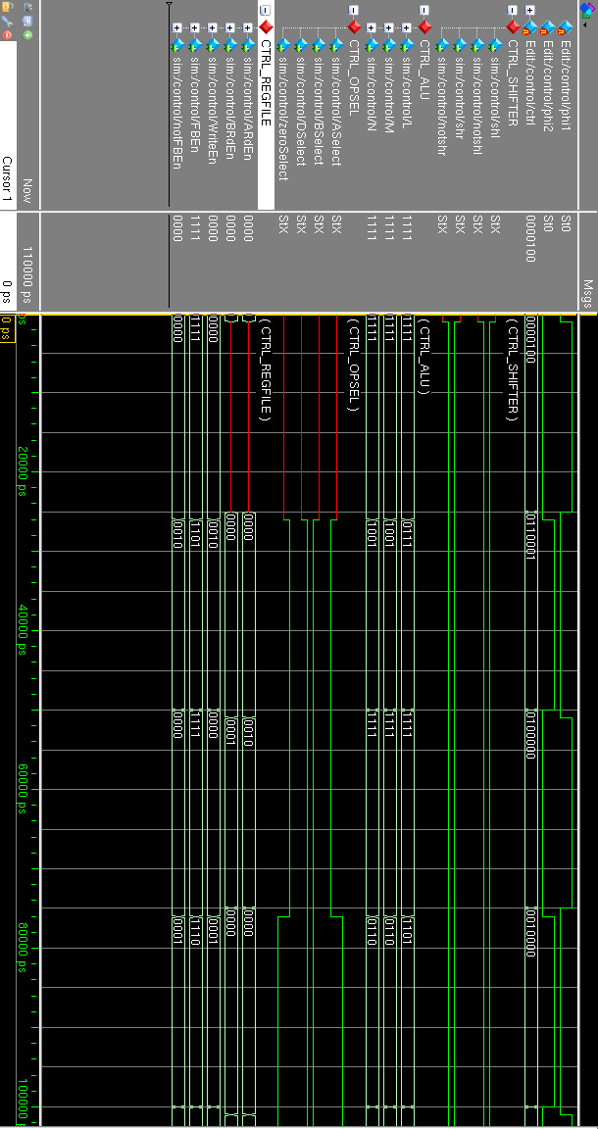
4)
compile -map_effort low
create_clock -name "phi1" -period 19.1 -waveform {"0" "9.3"} {"phi1"}
create_clock -name "phi2" -period 19.1 -waveform {"9.55" "18.85"} {"phi2"}
set_max_delay 0.2 -from {"phi1"} -to {"phi1_1"}
set_max_delay 0.2 -from {"phi1"} -to {"phi1_2"}
set_max_delay 0.2 -from {"phi1"} -to {"phi1_3"}
set_max_delay 0.2 -from {"phi2"} -to {"phi2_1"}
set_max_delay 0.2 -from {"phi1"} -to {"notphi1_1"}
set_max_delay 0.2 -from {"phi1"} -to {"notphi1_1"}
set_output_delay -clock phi1 -max 0 "ARdEn"
set_output_delay -clock phi1 -max 0 "BRdEn"
set_output_delay -clock phi1 -max 2.2 "ASelect"
set_output_delay -clock phi1 -max 2.2 "zeroSelect"
set_output_delay -clock phi1 -max 2.2 "DSelect"
set_output_delay -clock phi1 -max 2.2 "BSelect"
set_output_delay -clock phi2 -max 0 "L"
set_output_delay -clock phi2 -max 0 "M"
set_output_delay -clock phi2 -max 3.5 "N"
set_output_delay -clock phi2 -max 6 "shr"
set_output_delay -clock phi2 -max 6 "shl"
set_output_delay -clock phi2 -max 6 "notshr"
set_output_delay -clock phi2 -max 6 "notshl"
set_output_delay -clock phi2 -max 7.5 "WriteEn"

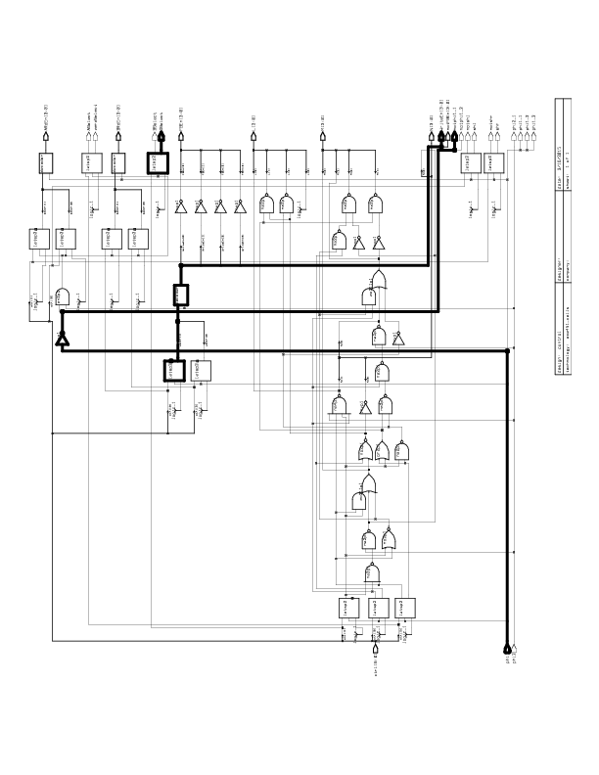
5 Bottom up a)

5 bottom up b)
****************************************
Report : area
Design : control
Version: X-2005.09
Date : Mon Mar 16 21:05:12 2015
****************************************

Library(s) Used:

gtech (File: /CMC/tools/synopsys/syn_vX-2005.09/libraries/syn/gtech.db)
ece451_cells (File: /cad2/ece451/synopsys/ece451_cells.db)

Number of ports: 55
Number of nets: 81
Number of cells: 43
Number of references: 10

Combinational area: 1517.040283
Noncombinational area: 2751.839355
Net Interconnect area: 2.386782

Total cell area: 4268.879883
Total area: 4271.266602

Information: This design contains unmapped logic. (RPT-7)
1
design_analyzer>
****************************************
Report : timing
-path full
-delay max
-max_paths 1
Design : control
Version: X-2005.09
Date : Mon Mar 16 21:05:12 2015
****************************************

Operating Conditions: nom_pvt Library: ece451_cells
Wire Load Model Mode: top

Startpoint: opsel_reg[0]
(positive level-sensitive latch clocked by phi2)
Endpoint: DSelect (output port clocked by phi1)
Path Group: phi1
Path Type: max

Des/Clust/Port Wire Load Model Library
------------------------------------------------
control q35_27k ece451_cells

Point Incr Path
-----------------------------------------------------------
clock phi2 (rise edge) 9.55 9.55
clock network delay (ideal) 0.00 9.55
opsel_reg[0]/G (latsp2) 0.00 9.55 r
opsel_reg[0]/Q (latsp2) 0.73 10.28 r
DSelect (out) 0.00 10.28 r
data arrival time 10.28

clock phi1 (rise edge) 19.10 19.10
clock network delay (ideal) 0.00 19.10
output external delay -2.20 16.90
data required time 16.90
-----------------------------------------------------------
data required time 16.90
data arrival time -10.28
-----------------------------------------------------------
slack (MET) 6.62

Startpoint: waddr_reg[1]
(positive level-sensitive latch clocked by phi1)
Endpoint: WriteEn[0] (output port clocked by phi2)
Path Group: phi2
Path Type: max

Des/Clust/Port Wire Load Model Library
------------------------------------------------
control q35_27k ece451_cells

Point Incr Path
-----------------------------------------------------------
clock phi1 (rise edge) 0.00 0.00
clock network delay (ideal) 0.00 0.00
waddr_reg[1]/G (latsp2) 0.00 0.00 r
waddr_reg[1]/Q (latsp2) 0.86 0.86 r
I3/a[1] (decoder) 0.00 0.86 r
I3/C24/Z (GTECH_OR2) 0.00 0.86 r
I3/I_2/Z (GTECH_NOT) 0.00 0.86 f
I3/C16/Z_0 (*SELECT_OP_2.4_2.1_4) 0.00 0.86 f
I3/x[0] (decoder) 0.00 0.86 f
WriteEn[0] (out) 0.00 0.86 f
data arrival time 0.86

clock phi2 (rise edge) 9.55 9.55
clock network delay (ideal) 0.00 9.55
output external delay -7.50 2.05
data required time 2.05
-----------------------------------------------------------
data required time 2.05
data arrival time -0.86
-----------------------------------------------------------
slack (MET) 1.19

Startpoint: phi1 (clock source 'phi1')
Endpoint: notphi1_1 (output port)
Path Group: default
Path Type: max

Des/Clust/Port Wire Load Model Library
------------------------------------------------
control q35_27k ece451_cells

Point Incr Path
-----------------------------------------------------------
phi1 (in) 0.00 0.00 r
U51/NQ (invp1) 0.27 0.27 f
notphi1_1 (out) 0.00 0.27 f
data arrival time 0.27

max_delay 0.20 0.20
output external delay 0.00 0.20
data required time 0.20
-----------------------------------------------------------
data required time 0.20
data arrival time -0.27
-----------------------------------------------------------
slack (VIOLATED) -0.07

1
design_analyzer>
****************************************
Report : timing
-path full
-delay max
-max_paths 1
Design : control
Version: X-2005.09
Date : Mon Mar 16 21:09:59 2015
****************************************

Operating Conditions: nom_pvt Library: ece451_cells
Wire Load Model Mode: top

Startpoint: opsel_reg[0]
(positive level-sensitive latch clocked by phi2)
Endpoint: DSelect (output port clocked by phi1)
Path Group: phi1
Path Type: max

Des/Clust/Port Wire Load Model Library
------------------------------------------------
control q35_27k ece451_cells

Point Incr Path
-----------------------------------------------------------
clock phi2 (rise edge) 9.55 9.55
clock network delay (ideal) 0.00 9.55
opsel_reg[0]/G (latsp2) 0.00 9.55 r
opsel_reg[0]/Q (latsp2) 0.73 10.28 r
DSelect (out) 0.00 10.28 r
data arrival time 10.28

clock phi1 (rise edge) 19.10 19.10
clock network delay (ideal) 0.00 19.10
output external delay -2.20 16.90
data required time 16.90
-----------------------------------------------------------
data required time 16.90
data arrival time -10.28
-----------------------------------------------------------
slack (MET) 6.62

Startpoint: waddr_reg[1]
(positive level-sensitive latch clocked by phi1)
Endpoint: WriteEn[0] (output port clocked by phi2)
Path Group: phi2
Path Type: max

Des/Clust/Port Wire Load Model Library
------------------------------------------------
control q35_27k ece451_cells

Point Incr Path
-----------------------------------------------------------
clock phi1 (rise edge) 0.00 0.00
clock network delay (ideal) 0.00 0.00
waddr_reg[1]/G (latsp2) 0.00 0.00 r
waddr_reg[1]/Q (latsp2) 0.86 0.86 r
I3/a[1] (decoder) 0.00 0.86 r
I3/C24/Z (GTECH_OR2) 0.00 0.86 r
I3/I_2/Z (GTECH_NOT) 0.00 0.86 f
I3/C16/Z_0 (*SELECT_OP_2.4_2.1_4) 0.00 0.86 f
I3/x[0] (decoder) 0.00 0.86 f
WriteEn[0] (out) 0.00 0.86 f
data arrival time 0.86

clock phi2 (rise edge) 9.55 9.55
clock network delay (ideal) 0.00 9.55
output external delay -7.50 2.05
data required time 2.05
-----------------------------------------------------------
data required time 2.05
data arrival time -0.86
-----------------------------------------------------------
slack (MET) 1.19

5 bottom up c)

Signal | Max delay
phi1_1 (out) | 0.00 f
phi1_2 (out) | 0.00 f
phi1_3 (out) | 0.00 f
notphi1_1 (out) | 0.27 f
WriteEn[0] (out) | 0.86 f
WriteEn[1] (out) | 0.86 f
WriteEn[2] (out) | 0.86 f
WriteEn[3] (out) | 0.86 r
shl (out) | 0.73 r
shr (out) | 0.73 r
notshl (out) | 0.59 f
notshr (out) | 0.59 f
N[3] (out) | 2.87 f
N[2] (out) | 2.32 r
N[0] (out) | 1.71 f
N[1] (out) | 1.37 r
M[1] (out) | 3.13 r
DSelect (out) | 0.73 r
zeroSelect (out) | 0.73 r
L[1] (out) | 2.87 f
L[2] (out) | 2.87 f
M[2] (out) | 2.80 r
ASelect (out) | 0.59 f
BSelect (out) | 0.59 f
M[3] (out) | 2.25 f
M[0] (out) | 2.09 f
L[3] (out) | 1.37 r
ARdEn[0] (out) | 0.86 r
ARdEn[1] (out) | 0.86 r
ARdEn[2] (out) | 0.86 r
BRdEn[0] (out) | 0.86 r
BRdEn[1] (out) | 0.86 r
BRdEn[2] (out) | 0.86 r
ARdEn[3] (out) | 0.86 r
BRdEn[3] (out) | 0.86 r

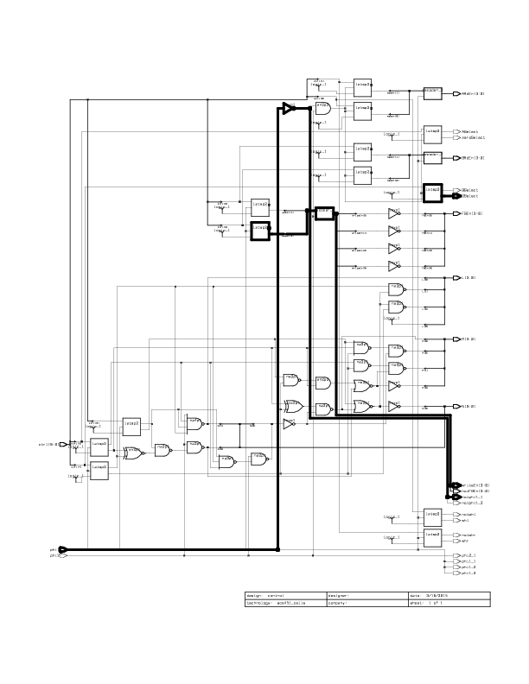
5 uniquify a)

5 uniquify b)

Library(s) Used:

ece451_cells (File: /cad2/ece451/synopsys/ece451_cells.db)

Number of ports: 55
Number of nets: 82
Number of cells: 43
Number of references: 12

Combinational area: 2875.319824
Noncombinational area: 2751.839355
Net Interconnect area: 2.141498

Total cell area: 5627.159668
Total area: 5629.300781
1
design_analyzer>
****************************************
Report : timing
-path full
-delay max
-max_paths 1
Design : control
Version: X-2005.09
Date : Mon Mar 16 21:24:35 2015
****************************************

Operating Conditions: nom_pvt Library: ece451_cells
Wire Load Model Mode: top

Startpoint: opsel_reg[0]
(positive level-sensitive latch clocked by phi2)
Endpoint: DSelect (output port clocked by phi1)
Path Group: phi1
Path Type: max

Des/Clust/Port Wire Load Model Library
------------------------------------------------
control q35_27k ece451_cells

Point Incr Path
-----------------------------------------------------------
clock phi2 (rise edge) 9.55 9.55
clock network delay (ideal) 0.00 9.55
opsel_reg[0]/G (latsp2) 0.00 9.55 r
opsel_reg[0]/Q (latsp2) 0.73 10.28 r
DSelect (out) 0.00 10.28 r
data arrival time 10.28

clock phi1 (rise edge) 19.10 19.10
clock network delay (ideal) 0.00 19.10
output external delay -2.20 16.90
data required time 16.90
-----------------------------------------------------------
data required time 16.90
data arrival time -10.28
-----------------------------------------------------------
slack (MET) 6.62

Startpoint: waddr_reg[0]
(positive level-sensitive latch clocked by phi1)
Endpoint: WriteEn[0] (output port clocked by phi2)
Path Group: phi2
Path Type: max

Des/Clust/Port Wire Load Model Library
------------------------------------------------
control q35_27k ece451_cells

Point Incr Path
-----------------------------------------------------------
clock phi1 (rise edge) 0.00 0.00
clock network delay (ideal) 0.00 0.00
waddr_reg[0]/G (latsp2) 0.00 0.00 r
waddr_reg[0]/Q (latsp2) 0.85 0.85 r
I3/a[0] (decoder_0) 0.00 0.85 r
I3/U37/NQ (invp1) 0.29 1.14 f
I3/U35/Q (an3p1) 0.58 1.72 f
I3/x[0] (decoder_0) 0.00 1.72 f
WriteEn[0] (out) 0.00 1.72 f
data arrival time 1.72

clock phi2 (rise edge) 9.55 9.55
clock network delay (ideal) 0.00 9.55
output external delay -7.50 2.05
data required time 2.05
-----------------------------------------------------------
data required time 2.05
data arrival time -1.72
-----------------------------------------------------------
slack (MET) 0.33

5 uniquify c)

Signal | Max Delay
notphi1_1 (out) | 0.27 f
phi1_1 (out) | 0.00 f
phi1_2 (out) | 0.00 f
phi1_3 (out) | 0.00 f
WriteEn[0] (out) | 1.72 f
WriteEn[2] (out) | 1.70 f
WriteEn[1] (out) | 1.70 f
WriteEn[3] (out) | 1.35 f
shl (out) | 0.73 r
shr (out) | 0.73 r
notshl (out) | 0.59 f
notshr (out) | 0.59 f
N[3] (out) | 2.70 f
N[2] (out) | 1.85 r
N[0] (out) | 1.39 f
N[1] (out) | 1.06 r
DSelect (out) | 0.73 r
zeroSelect (out) | 0.73 r
ASelect (out) | 0.59 f
BSelect (out) | 0.59 f
L[1] (out) | 2.70 f
L[2] (out) | 2.66 f

5 flatten a)

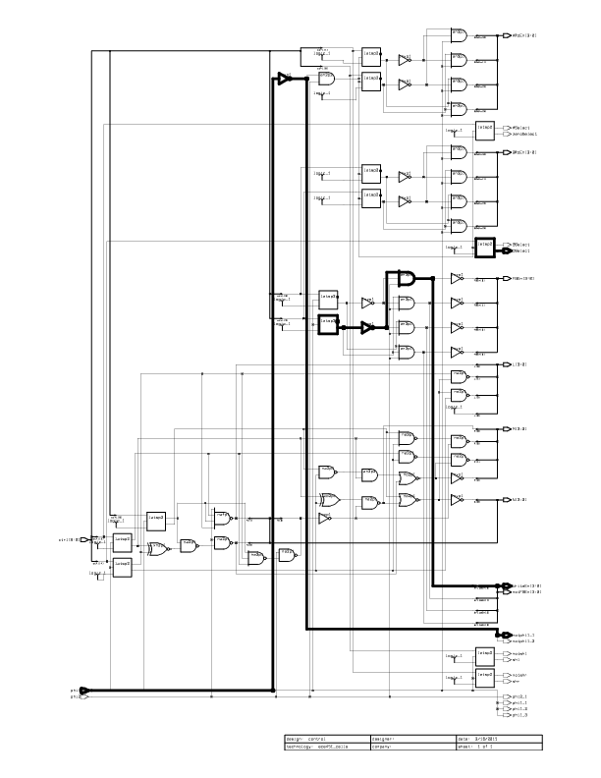

5 flatten b)

****************************************
Report : area
Design : control
Version: X-2005.09
Date : Mon Mar 16 21:33:17 2015
****************************************

Library(s) Used:

ece451_cells (File: /cad2/ece451/synopsys/ece451_cells.db)

Number of ports: 55
Number of nets: 88
Number of cells: 58
Number of references: 10

Combinational area: 2875.319824
Noncombinational area: 2751.839355
Net Interconnect area: 2.141498

Total cell area: 5627.159668
Total area: 5629.300781
1
design_analyzer>
****************************************
Report : timing
-path full
-delay max
-max_paths 1
Design : control
Version: X-2005.09
Date : Mon Mar 16 21:33:17 2015
****************************************

Operating Conditions: nom_pvt Library: ece451_cells
Wire Load Model Mode: top

Startpoint: opsel_reg[0]
(positive level-sensitive latch clocked by phi2)
Endpoint: DSelect (output port clocked by phi1)
Path Group: phi1
Path Type: max

Des/Clust/Port Wire Load Model Library
------------------------------------------------
control q35_27k ece451_cells

Point Incr Path
-----------------------------------------------------------
clock phi2 (rise edge) 9.55 9.55
clock network delay (ideal) 0.00 9.55
opsel_reg[0]/G (latsp2) 0.00 9.55 r
opsel_reg[0]/Q (latsp2) 0.73 10.28 r
DSelect (out) 0.00 10.28 r
data arrival time 10.28

clock phi1 (rise edge) 19.10 19.10
clock network delay (ideal) 0.00 19.10
output external delay -2.20 16.90
data required time 16.90
-----------------------------------------------------------
data required time 16.90
data arrival time -10.28
-----------------------------------------------------------
slack (MET) 6.62

Startpoint: waddr_reg[0]
(positive level-sensitive latch clocked by phi1)
Endpoint: WriteEn[0] (output port clocked by phi2)
Path Group: phi2
Path Type: max

Des/Clust/Port Wire Load Model Library
------------------------------------------------
control q35_27k ece451_cells

Point Incr Path
-----------------------------------------------------------
clock phi1 (rise edge) 0.00 0.00
clock network delay (ideal) 0.00 0.00
waddr_reg[0]/G (latsp2) 0.00 0.00 r
waddr_reg[0]/Q (latsp2) 0.85 0.85 r
I3/U37/NQ (invp1) 0.29 1.14 f
I3/U35/Q (an3p1) 0.58 1.72 f
WriteEn[0] (out) 0.00 1.72 f
data arrival time 1.72

clock phi2 (rise edge) 9.55 9.55
clock network delay (ideal) 0.00 9.55
output external delay -7.50 2.05
data required time 2.05
-----------------------------------------------------------
data required time 2.05
data arrival time -1.72
-----------------------------------------------------------
slack (MET) 0.33

5 flatten c)

Signal | Max Delay
notphi1_1 (out) | 0.27 f
phi1_1 (out) | 0.00 f
phi1_2 (out) | 0.00 f
phi1_3 (out) | 0.00 f
WriteEn[0] (out) | 1.72 f
WriteEn[2] (out) | 1.70 f
WriteEn[1] (out) | 1.70 f
WriteEn[3] (out) | 1.35 f
shl (out) | 0.73 r
shr (out) | 0.73 r
notshl (out) | 0.59 f
notshr (out) | 0.59 f
N[3] (out) | 2.70 f
N[2] (out) | 1.85 r
N[0] (out) | 1.39 f
N[1] (out) | 1.14 r
DSelect (out) | 0.73 r
zeroSelect (out) | 0.73 r
ASelect (out) | 0.59 f
BSelect (out) | 0.59 f
ASelect (out) | 0.51 r
BSelect (out) | 0.51 r
L[1] (out) | 2.70 f
L[2] (out) | 2.66 f

6) uniquify script

read -format verilog control.v
Current_design control
Uniquify
Characterize -cons {I1, I2, I3}
Write -o top.db

Current_design decoder_0
Write_script > decoder_0.scr
Write -o decoder_0.db

Current_design decoder_1
Write_script > decoder_1.scr
Write -o decoder_1.db

Current_design decoder_2
Write_script > decoder_2.scr
Write -o decoder_2.db

remove_design -designs

read decoder_0.db
include decoder_0.scr
compile -map_effort low
write -o decoder_0.db

read decoder_1.db
include decoder_1.scr
compile -map_effort low
write -o decoder_1.db

read decoder_2.db
include decoder_2.scr
compile -map_effort low
write -o decoder_2.db

read top.db
read decoder_0.db
read decoder_1.db
read decoder_2.db

Current_design control
compile -map_effort low

7) a)
Structural is easier because the behaviour is more intuitive compared to behavioural. Defining the structure of your circuit makes more sense for designers compared to using always blocks to define behaviour.

b)
Inaccuracies can be from extremely pessismtic or optimistic estimates, or can be from wires being placed slightly off due to lambda. You can reduce these by running a more accurate simulator for longer. Could also be from voltage problems or large amounts of noise, which might cause a problem with the capacitances.

c)
Bottom up is easy to implement, uniquify is harder, and flatten is the hardest. Uniquify also required writing a script, which was mildly annoying. Bottom up also has the smallest area, with flatten having the largest, and uniquify almost being the same size as flatten. However bottom up also has the worst timing, with uniquify having the best timing. Overall each method created pretty similar results, with area increasing by roughly 20% and timing decreasing by about 10% when comparing bottom up to flatten.

